Product inventory management

1.Project Overview:
1.1 Purpose:
The Product Inventory Management System is a backend-focused web application developed using Node.js, Express.js, and MongoDB, designed to provide a secure and scalable solution for managing product data through RESTful APIs. The system enables users to create accounts, log in securely, and access protected routes using JWT-based authentication, ensuring that only authorized users can perform operations. It supports complete CRUD functionality, allowing users to add new products, view their inventory, update product details such as price or quantity, and delete items when needed.

1.2 Key Objectives:
- Provide secure JWT-based user authentication and authorization for protected API access.
- Enable efficient product inventory management through RESTful CRUD operations.
- Ensure user-specific data isolation so each user can manage only their own products.
- Implement scalable backend architecture using Node.js, Express.js, and MongoDB.
- Deliver fast and reliable API responses with proper validation and error handling.

1.3 Target Audience:
- Retail Store Owners: Retailers use inventory management systems to track products, monitor stock levels, and avoid overstocking or running out of items.
- Warehouse Managers: They use the system to organize goods in storage, track incoming and outgoing products, and manage warehouse operations efficiently.
- Small and Medium Businesses (SMBs): Businesses that sell physical products use inventory systems to control their stock, reduce losses, and improve productivity.
- E-commerce Businesses: Online stores use inventory systems to track products, update stock automatically, and manage orders.
- Manufacturing Companies: Manufacturers use inventory management to monitor raw materials, work-in-progress items, and finished goods.
- Supply Chain Managers: They track the movement of goods from suppliers to warehouses and finally to customers.

2. PROJECT ARCHITECTURE

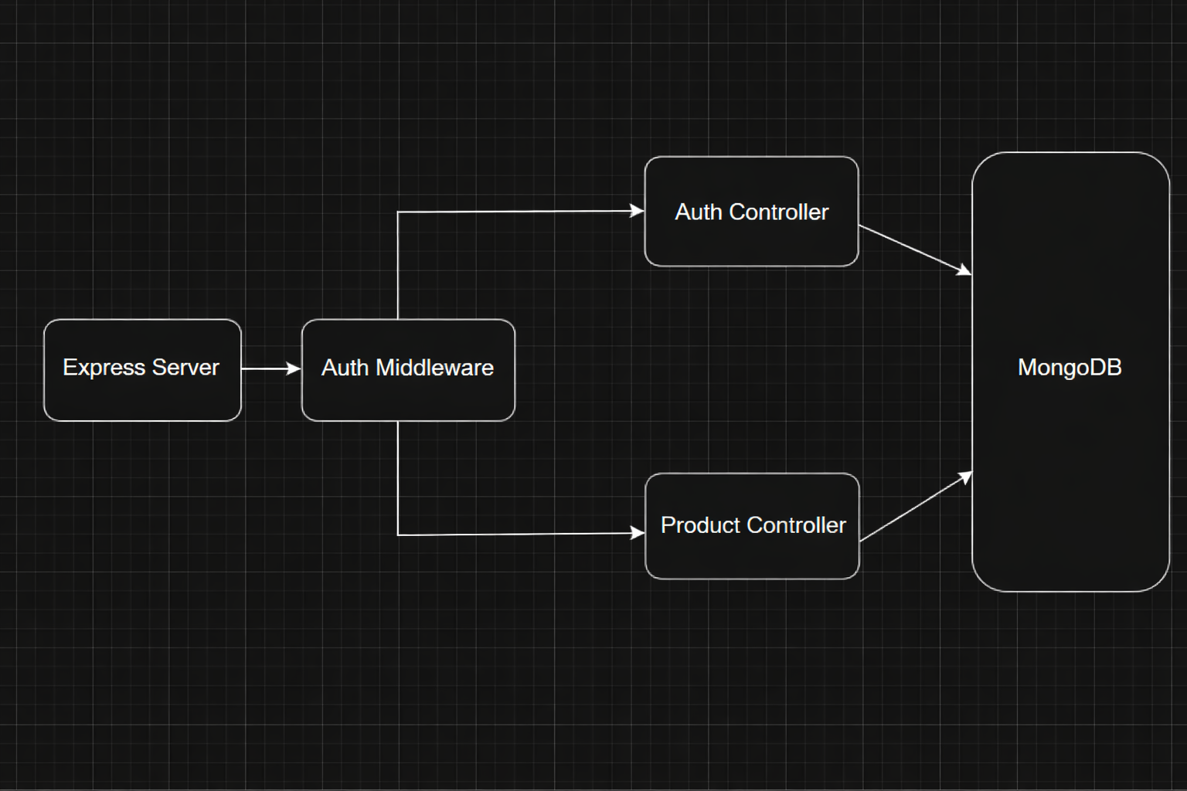

2.1.Express Server :
In this Product Inventory Management project, the Express Server acts as the main backend server that receives all requests from the frontend or API tools like Postman. It manages the routing of requests such as login, product creation, and product retrieval. The server organizes the application structure and connects different components of the system. It forwards incoming requests to the authentication middleware for security checks. This makes the Express server the central point that controls the application flow.
2.2.Auth Middleware:
In this project, the Auth Middleware is used to protect the inventory system from unauthorized access. Whenever a user tries to perform an action like adding or updating a product, the middleware checks whether the user is authenticated. It verifies the login token before allowing access to the system’s resources. If the authentication is valid, the request proceeds to the controller; otherwise, access is denied. This ensures that only authorized users can manage the product inventory.

2.3.Auth Controller:
The Auth Controller in this project handles all user authentication processes such as registration and login. When a user enters login credentials, the controller validates the information with the database. If the credentials are correct, it generates a token that allows the user to access protected features of the system. It ensures secure login and user management within the inventory system. This controller plays an important role in maintaining system security.
2.4.Product Controller:
The Product Controller is responsible for managing all product-related operations in the inventory management project. It handles actions such as adding new products, updating product details, deleting products, and retrieving product information. When a request related to products is received, this controller processes the request and performs the required operation. It communicates with the MongoDB database to store or retrieve product data. This helps maintain accurate product records in the system.
2.5.MongoDB:
MongoDB is used as the database in this project to store all application data. It keeps records of users and product details such as product name, quantity, price, and category. The controllers interact with MongoDB to perform operations like inserting new products, updating product information, or retrieving product lists. Its document-based structure makes data storage flexible and efficient. This database ensures that all inventory information is stored securely and can be accessed whenever needed.

2.6.TECHNICAL ARCHITECTURE
Backend Architecture (Node.js + Express)
• Controllers: Handle authentication and product logic
• Models: Define database schema
• Routes: API endpoints for authentication and products
• Middleware: JWT verification and error handling
• Configuration: Environment variables and database connection

Database Architecture (MongoDB)
Users Collection:
• _id
• name
• email
• password (hashed)
• timestamps
Products Collection:
• _id
• userId (reference to user)
• name
• price
• quantity
• description
• timestamps
Relationship: One User → Many Products
Indexes:
• email (unique)
• userId
• product name
ER Diagram
ER diagram showing User → Product relationship:
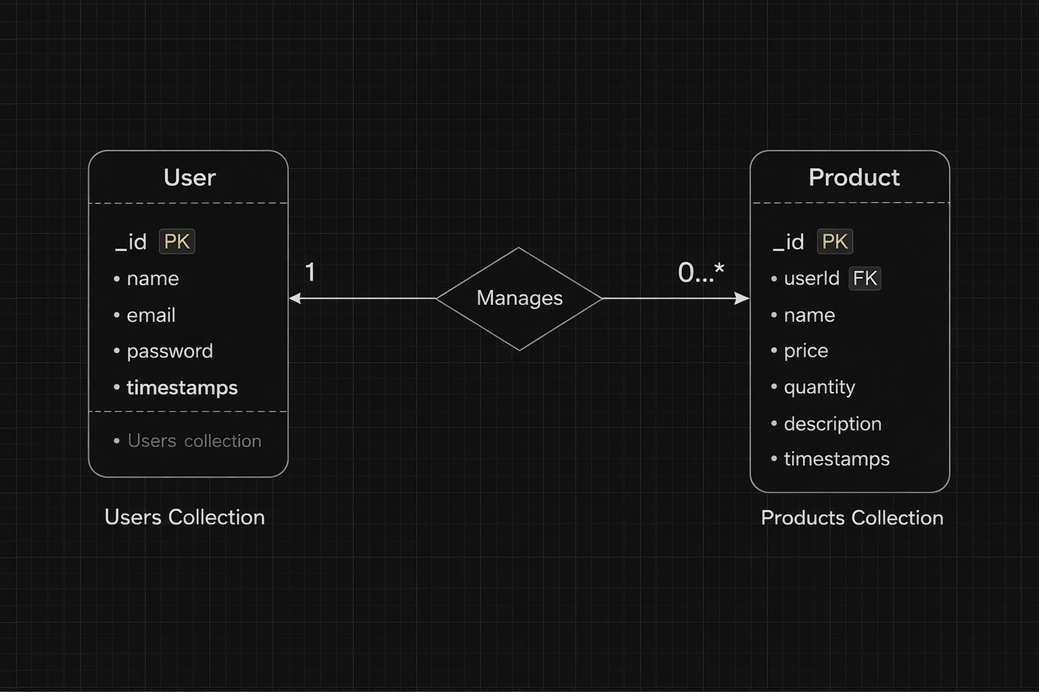

3. SETUP INSTRUCTIONS
3.1.Prerequisites:
Before setting up product inventory management ensure that the following tools and technologies are installed on your system:
  - Node.js – JavaScript runtime environment.
  - MongoDB – Database for storing user data, projects, and chat messages.
  - Git – For cloning and version control.
  - Express.js – Backend framework for handling APIs and server logic.
  - Mongoose – ODM (Object Data Modeling) library for MongoDB.
  - Visual Studio Code – Recommended IDE for development.

3.2.Installation steps

3.2.1.Node.js
- Knowledge: basic JavaScript (variables, functions, promises/async-await), basic command-line use (terminal / PowerShell), JSON, and git (recommended).
- System: Windows / macOS / Linux (x64 or arm64); 2GB+ RAM recommended; internet to download installers.
- Tools to have ready: a terminal (CMD/PowerShell/WSL on Windows, Terminal on macOS/Linux), a code editor (VS Code recommended).

Step-by-step installation
Windows — easiest: official installer (or use npm-windows for version management)
Official installer (quick)

- Visit the official Node.js downloads page and download the Windows .msi (choose the LTS build).
- Run the MSI and accept defaults (it will install node and npm and add to PATH).
- Open PowerShell or Command Prompt and verify:
node -v
npm -v
you’re done. nodejs.org
If you want multiple Node versions / safer global installs — use npm for Windows
- Install npm-windows (download and run the installer from the npm-windows releases).
- After install, open a new admin PowerShell or CMD and use:
npm install lts
npm list
npm use <version> # e.g. npm use 18.16.0 OR `npm use lts` if supported
node -v
npm-windows lets you switch versions without re-installers. GitHub+1
npm -v
you’re done.

3.2.2.MongoDB:
  - Knowledge Prerequisites
  - Basic database concepts: collections, documents, CRUD (Create, Read, Update, Delete).
  - Basic command line/terminal usage.
  - JSON knowledge (MongoDB stores data in BSON, similar to JSON).
  - (Optional) Networking basics: ports, IP binding, authentication.
System Prerequisites
  - OS: Windows (x64/arm64 supported).
  - Processor: 64-bit, 1 GHz+ recommended.
  - RAM: Minimum 2 GB (4 GB+ recommended for dev; higher for prod).
  - Disk space: At least 5–10 GB free (MongoDB stores large amounts of data).
  - Port: MongoDB runs on 27017 by default (make sure it’s free/unblocked).
Software Prerequisites
  - Administrator (to install packages/services).
  - Package manager (apt, yum, Homebrew) OR direct installer.
  - MongoDB Shell (mongosh) – required to interact with MongoDB.
  - MongoDB Compass (GUI) – optional but recommended for beginners.
  - Docker (optional) – for containerized setup.
3.2.3.Git
System prerequisites
  - OS: Windows
  - Permissions: Administrator (Windows)
  - Network: Internet access (for cloning/pushing remote repos like GitHub, GitLab, Bitbucket).
Software prerequisites
  - Text/code editor (VS Code recommended).
  - SSH client (optional, for GitHub/GitLab SSH connections).
Github account creation:

1. Sign in to GitHub
- Go to GitHub.
- Log in to your GitHub account. If you don't have one, you can sign up for free.

2. Create a New Repository
- Once logged in, click on the + icon in the top right corner of the page.
- Select "New repository" from the dropdown menu.

3. Fill in Repository Details
You'll need to fill out the following fields:
- Repository Name: Choose a name for your repository (e.g., my-project).
- Description (optional): Provide a brief description of your project (e.g., "A cool web app").
- Public or Private: Choose whether your repository will be public (anyone can see it) or private (only you and collaborators can access it).
- Initialize with README: If you want to add a README file (which is helpful for explaining your project), check this box.
- Add .gitignore (optional): You can choose a template for your .gitignore file, depending on your project's language or framework (e.g., Python, Node, etc.).
- Choose a License (optional): You can choose a license if you'd like to specify how others can use your code.

4. Create the Repository
- Once you've filled everything out, click the Create repository button.

5. Clone the Repository (Optional)
- After the repository is created, you'll be taken to the new repository's page.
- To clone it to your local machine, copy the clone URL (either HTTPS or SSH) from the "Code" button.
- In your terminal, run the following command:
- git clone<repository-url>

6. Start Adding Files
- Now you can start adding files to your repository either through the GitHub website or by pushing files from your local machine.
That's it! You've created a new GitHub repository. Let me know if you need help with the next steps, like pushing files to GitHub.

3.2.4.Express.js – Mongoose – Visual Studio Code
  - Prerequisites (Theory)
  - JavaScript & Node.js → needed since Express runs on Node.
  - MongoDB knowledge → Mongoose is an ODM for MongoDB.
  - REST API concepts → to design routes/endpoints.
  - Visual Studio Code → editor to write and manage the project.
  - Node.js & npm installed → to run server and install packages.
  - MongoDB installed or Atlas account → for database.

- Installation Steps:
# Clone the repository git clone
# Install client dependencies cd client npm install
# Install server dependencies cd
../server npm install
#Install server dependencies cd
../server npm run dev
4.FEATURES

4.1.Core Features:
S.No | Feature | Description
1 | User Authentication | JWT-based register and login system
2 | Product CRUD | Add, view, update and delete products
3 | Private Data Access | Users access only their own products
4 | Product Search | Search products by name
5 | Secure API | Middleware protected routes

4.2.Roles and Responsibility
4.2.1.User
- Registration: Register using name, email and password
- Login: Login using registered credentials
- Add Product: Create product with name, price, quantity and description
- Edit Product: Update existing product
- Delete Product: Remove product from inventory
- Search Product: Search products using keyword
4.2.3.User Flow
- The user sends a register/login request.
- The backend generates a JWT token.
- The user sends a token in the Authorization header.
- Middleware verifies the token.
- The controller performs CRUD operations.
- MongoDB stores or retrieves product data.
- API sends response.

5.FOLDER STRUCTURE

server/
│
├── node_modules/
├── src/
│ ├── controllers/
│ ├── db/
│ ├── middlewares/
│ ├── models/
│ ├── routes/
│ └── server.js
│
├── .env
├── .gitignore
├── package-lock.json
└── package.json

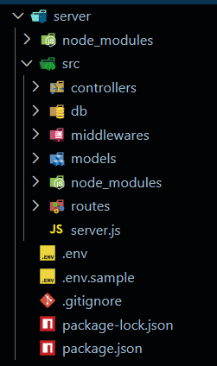

5.1.Initialize Node.js Project:
Open terminal inside the server folder and run:
npm init -y
This creates the package.json file which manages project dependencies.

5.2.Install Required Packages:
Install backend dependencies:
npm install express mongoose cors dotenv jsonwebtoken bcryptjs

Package Purpose:
- express → Backend framework
- mongoose → MongoDB connection
- cors → Cross-origin requests
- dotenv → Environment variables
- jsonwebtoken → Authentication
- bcryptjs → Password hashing
5.3.Create Environment File:
Create a .env file in the root of the server folder.
Example:

PORT=5000
MONGO_URI=your_mongodb_connection_string
JWT_SECRET=your_secret_key

Backend Development
5.4.Setup Express Server:
Inside src/server.js, create the basic Express server.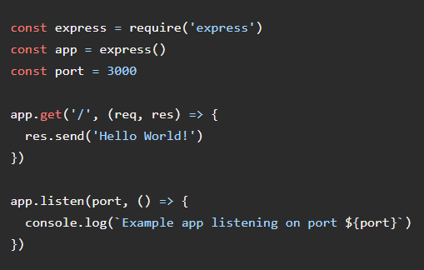

5.5.Create Controllers:
Inside: src/controllers/
Create:
auth.controller.js

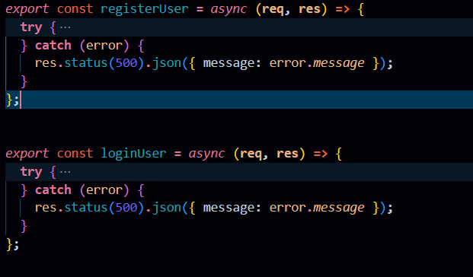

5.6.Create Routes
Inside: src/routes/
Create:
auth.routes.js
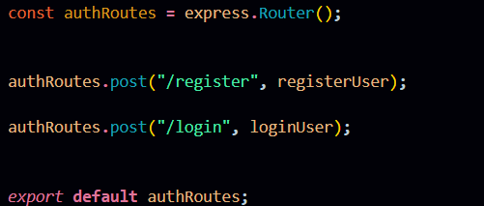

5.7.Auth Routes:
Auth routes handle user authentication by providing endpoints for registration and login. These routes connect incoming requests to the Auth Controller to create new users and generate JWT tokens for secure access.
product.routes.js

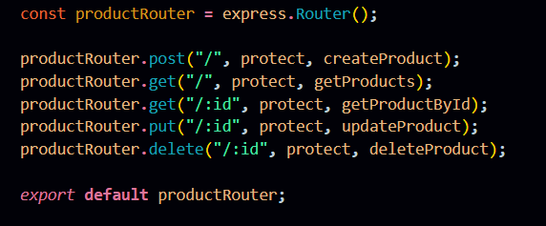

5.8.Product Routes:
Product routes manage all inventory-related operations such as creating, retrieving, updating, and deleting products. These routes are protected using authentication middleware to ensure only authorized users can access their own product data.

Connect Routes to Server
Import all routes into server.js

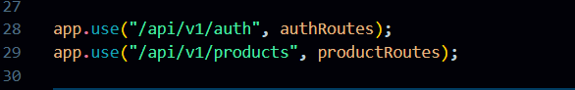
These route configurations connect the authentication and product APIs to the main Express server using versioned endpoints. The /api/v1/auth path handles all user authentication requests, while /api/v1/products manages product-related operations, helping maintain a structured and scalable API architecture.
Database Configuration and Setup
- Create MongoDB Atlas cluster
- Add connection string to .env
- Connect DB before API testing.
Database Connection:
Create a file inside: src/db/db.js
Purpose: Connect backend to MongoDB using mongoose.
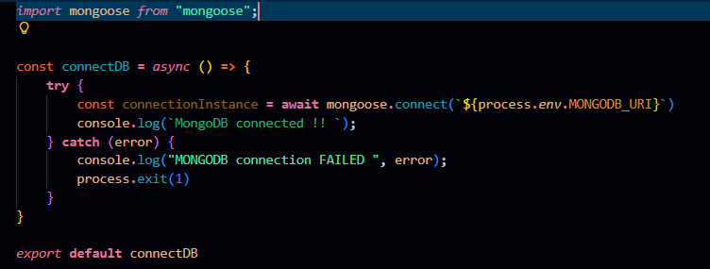

The connectDB function establishes a connection between the application and MongoDB using Mongoose and environment-based configuration. It ensures the server starts only after a successful database connection and logs an error message if the connection fails.
5.9.Create Models:
Inside src/models/ create:
- User.js
- Product.js

User Model:
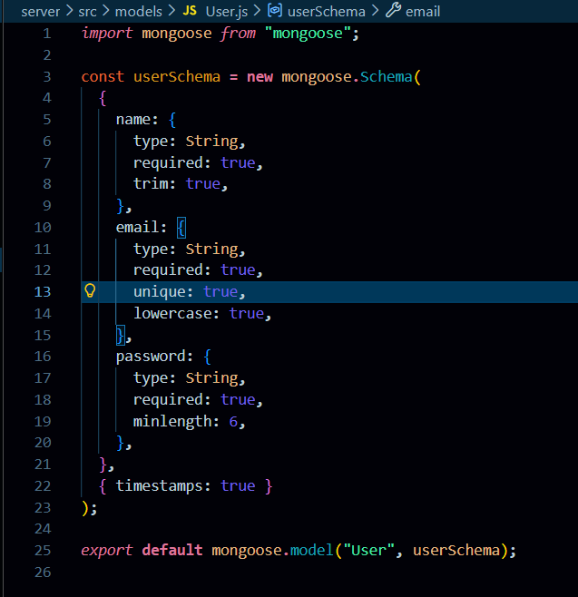
5.10.User Schema:
The User schema defines the structure for storing user details such as name, email, and hashed password in the database. It supports secure authentication and maintains timestamps for record tracking.
Product Model:
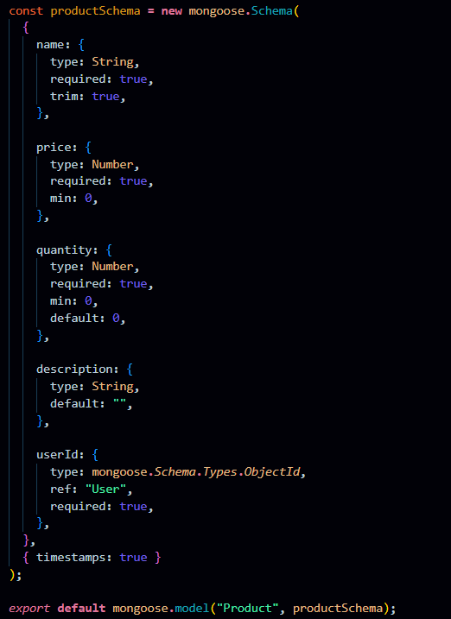

Product Schema:
The Product schema represents inventory items and includes fields like name, price, quantity, description, and a userId reference. It ensures each product is linked to its owner, enabling private data access and management.

5.11Use Thunder Client to test APIs:
Test APIs:
5.11.1.Register User:

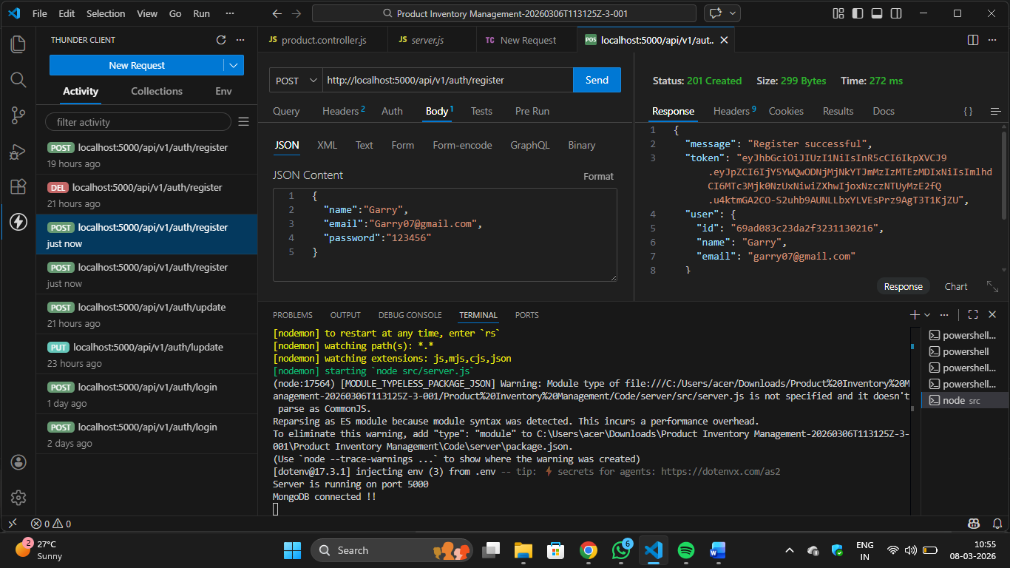
Register:
The register functionality allows new users to create an account by submitting their details, which are validated and securely stored with a hashed password. It ensures unique user creation before granting access to the system.

5.11.2.login user: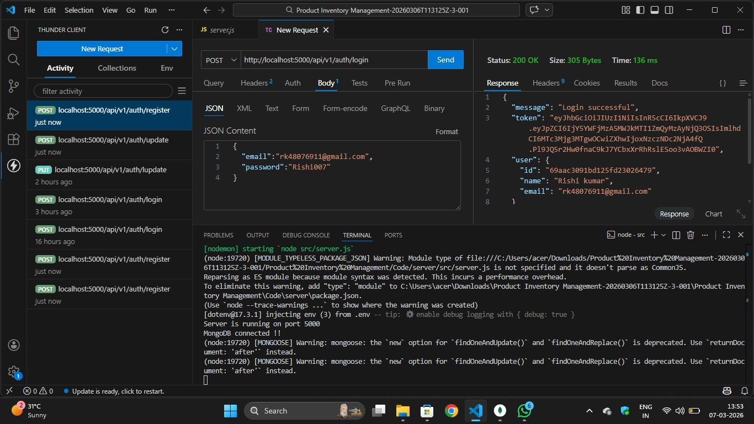
Login:
The login functionality verifies user credentials and generates a JWT token upon successful authentication. This token is used to access protected routes securely.
5.11.3. Create Product
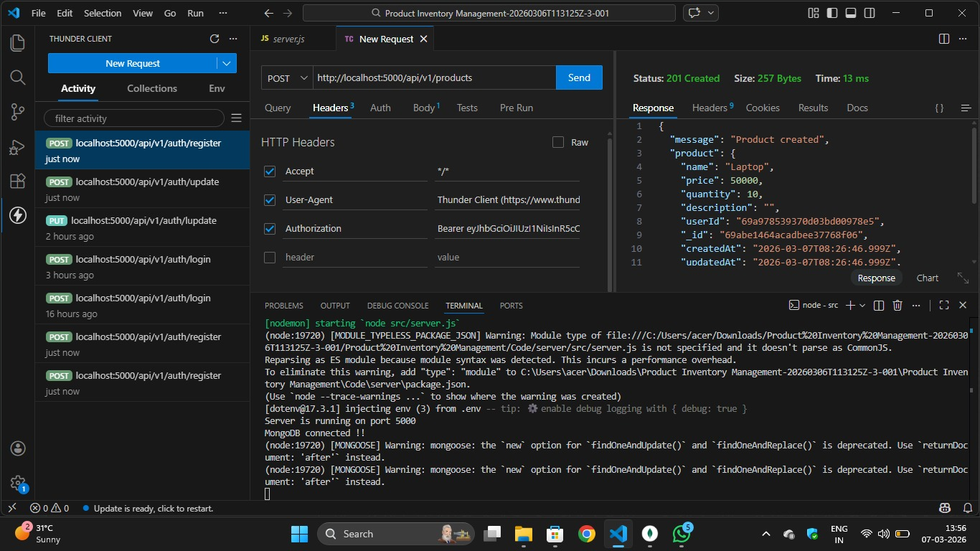
Create Product:
Allows an authenticated user to add a new product to their inventory by submitting product details.
5.11.4. Get all Products:
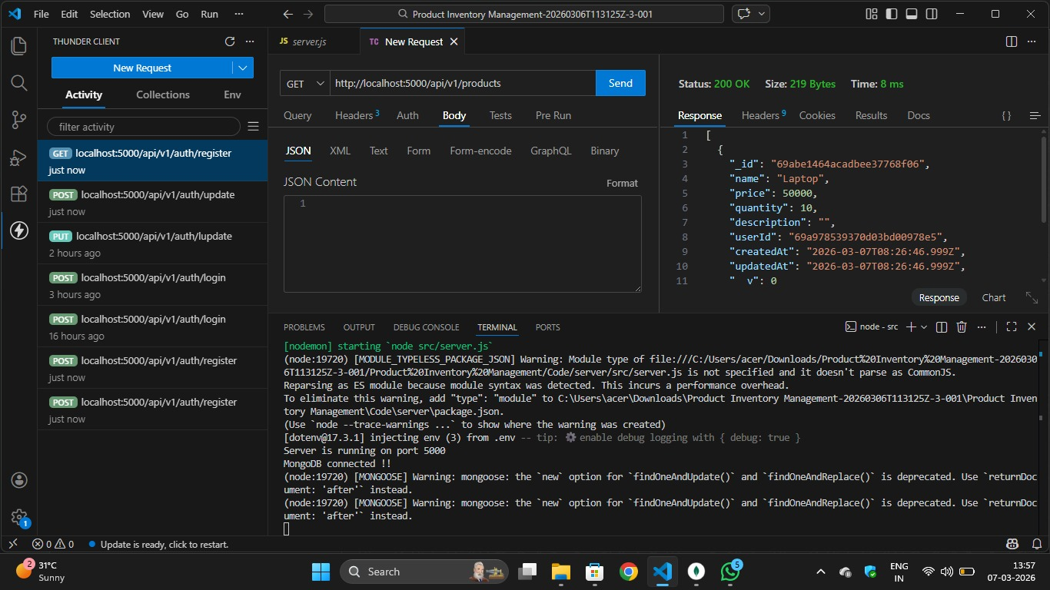
Get all Products:
Fetches all products that belong to the logged-in user. It ensures users can view only their own inventory data.
5.11.5. Update Product:
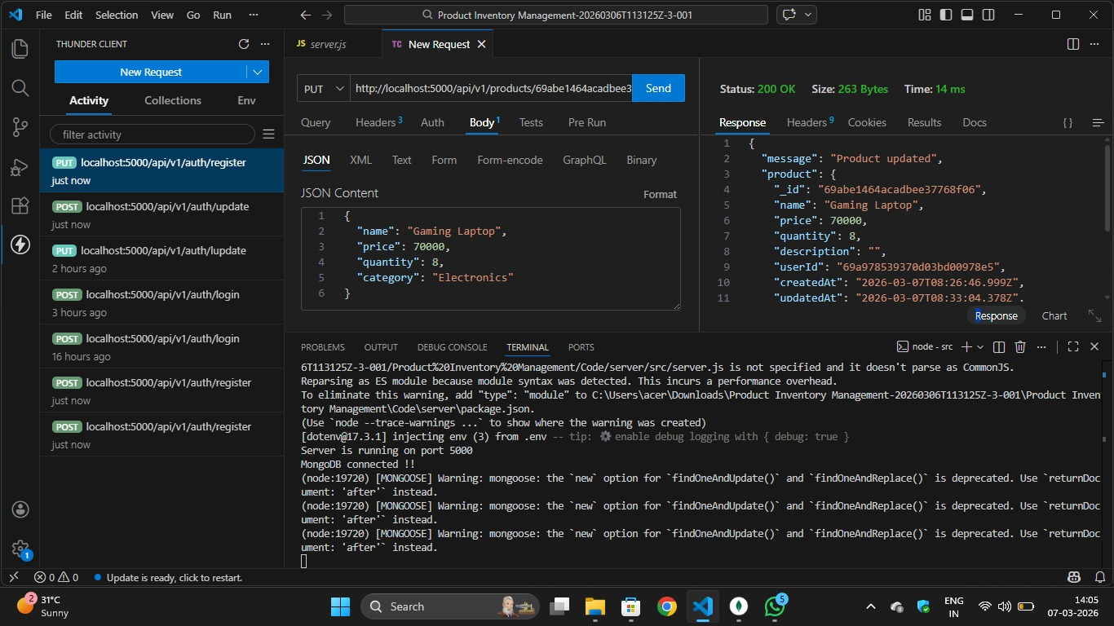

Update Product:
Enables users to modify existing product details such as name, price, or quantity. The system verifies ownership before allowing any updates.
5.11.6. Delete Product:
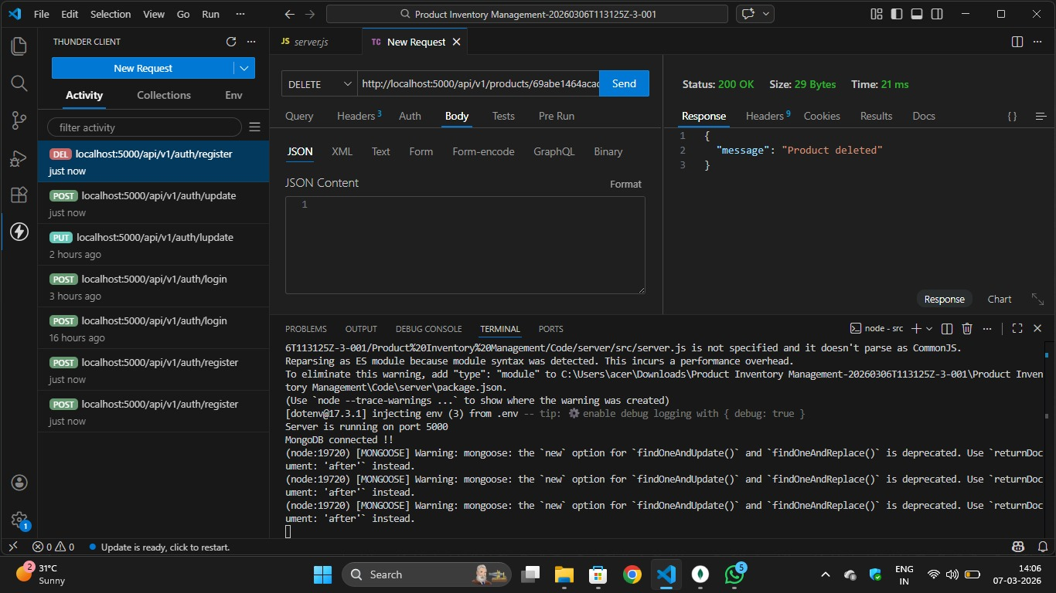
Delete Product:
Allows users to permanently remove a product from their inventory. The operation is protected to ensure only the product owner can delete it.

5.11.7.MongoDB Compass:
